Please email the completed Resource Order Form to:
healthpromotion@purchasepoint.com.au
or fax to 8234 0988
or post to: Purchase Point Australia
10 Aristotle Close
GOLDEN GROVE 5125

Get Healthy Information and Coaching Service®
Print Resource Order Form for South Australia

ITEM | CODE –  Office use only | Maximum per order | Quantity ordered
Small Leaflet – pad of 100  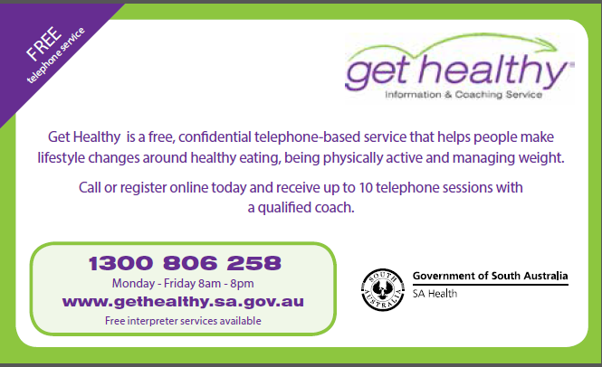 | GH008 | 10
Flyer – DL single page | GH011 | 50
A3 Poster | GH012 | 10

Please complete the following details.

Contact person | Position

Organisation name
Street address (PO Box not suitable) | Suburb  Postcode
e-mail address | Telephone
Date items are required (allow 7 to 10 working days  to be processed) | (dd/mm/yy)

If items are required for a specific date (e.g. event), ensure you allow a minimum of 10 working days before this date for your items to be available for collection or received.
Complete this section below if you wish to collect the resources from the warehouse
(Purchase Point Australia, 10 Aristotle Close GOLDEN GROVE 5125)

Name of person collecting the resource(s)

Date to be collected

(dd/mm/yy)
e-mail address |  | Telephone

Your answers to the questions below will assist SA Health to manage resources for the Get Healthy service.

1. Type of organisation (Please tick)
Community organisations, Local Government (Councils), and Community and neighbourhood houses and centres | SA Health – LHN / Hospital / Community Health / GP Plus
Medicare Locals / Primary Health Networks / GP Networks | Health – Private  GP / Allied Health / Hospital
State Government departments or programs | Education - University, TAFE

Other (Please describe)

Please email the completed Resource Order Form to:
healthpromotion@purchasepoint.com.au
or fax to 8234 0988
or post to: Purchase Point Australia
10 Aristotle Close GOLDEN GROVE 5125

